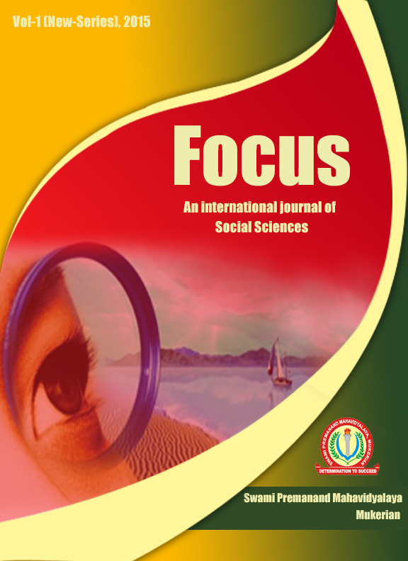
Focus
An International Journal of Social Sciences

Vol. 1 (New Series), 2016

Referred Journal



Swami Premanand Mahavidyalaya
Railway Road, Mukerian(HSP.)
Journal email: focus.jrnl@gmail.com
College email: principalspn.mex@gmail.com
Website:www.spncollegemukerian.org
Phone:01883-244070,248307 Fax:01883-244231

Focus: An International Journal of Social Sciences

- Chief Patron Sh. Rajan Makkar
President
Swami Premanand Mahavidyalaya,
Mukerian.
- Patron Dr. Kawaljit Kaur
Principal
Swami Premanand Mahavidyalaya,
Mukerian.
- Editors
Dr. Devinder singh (Associate Professor, Department of Political Science)
Dr. Pushpinder Kumari (Associate Professor, Department of History)

- Editorial Board
Prof. William Russel Dr. Amandeep
Director Deptt. of History
Central University of Florida, Guru Nanak Dev University,
U.S.A Amritsar
Dr. Shaveta Kohli Dr. Roniki Ram
Deptt. of Economics Deptt. of Political Science
Central University, Panjab University,
Jammu. Chandigarh
Dr. Paru Bal Sidhu Dr. Sukhmani Bal Riar
Deptt. of Ancient Studies, Deptt. of History,
Panjab University, Panjab University,
Chandigarh. Chandigarh.

- Advisory Board
Dr. Sukhwant Singh Dr. Rajesh Dogra
Professor, Deptt. of History Professor, Deptt. of Commerce,
G.N.D.U, Amritsar Govt. College, Hoshiarpur

Dr. Preet Mohinder Pal Singh, Dr. Neeru Sharma
Principal, Deptt. of Economics Deptt. of Pol. Science
Khalsa College, Garh Shankar B.D. Arya Girls College, Jalandhar Cantt
Published By:
Swami Premanand Mahavidyalaya,
Railway Road, Mukerian (HSP.)

PRESIDENT’S MESSAGE

I am glad to know that the vision of some of the learned teachers of this college has come true through their persistent and persevering efforts and the first issue of our Journal on Social Sciences “Focus” will soon see the light of the day. I heartily felicitate the editors for their initiative and worthy achievement. I am hopeful that the creative articles of various learned scholars will contribute a lot in building a healthy and peaceful society. The journal speaks tons of strenuous efforts put in by the editors and contributors. It also speaks volumes of their intellectual acumen, erudition and fecund imaginative drive. I strongly believe that it will create an aura of conducive environment for intellectual growth of students of our prestigious institution. It will also enthuse and encourage other teachers and students to whet and hone their intellectual faculties to come forward with their contributions. I pray to God to empower our shrine of learning to become a powerful instrument in dissemination of righteous learning, leading to peaceful and joyful living for mankind.

PRINCIPAL’S MESSAGE

My heart is exhilarated with pride and elation to acknowledge with thanks the efforts of the editors for bringing out the first issue of the International Journal on Social Sciences entitled “Focus”. This is a great leap forward made by the college towards social, moral, intellectual and spiritual upliftment of society. An integrated study of social sciences will lead to strengthening our inner life and help in establishing a better social set-up based on harmonious relationships. Further, such a study will edify, enrich and ennoble mankind by teaching ways for holistic living. I express my deep sense of gratitude to the galaxy of intellectual luminaries who have contributed to this journal, scholarly, illuminating and thought-provoking articles. Their erudition will stir up the souls of others also to refurbish their minds and intellects for making contribution to this noble task. I also congratulate the learned scholars of the college who have taken the arduous responsibility of publishing this journal. They have added one more laurel to a number of laurels already achieved by our college.
Lastly, a few words by way of reminder to the editors and contributors: An original article is the ‘brain-child’ of its writer. It requires painstaking efforts (like labor pains) to produce the ‘brain-child’. So the editor and contributor will have to make ceaseless efforts for more rewarding honors and esteem in future.

EDITORS’S NOTE

FOCUS: An International Journal of Social Sciences focuses on social formation, cultural articulation and political organization in the perspectives of national and international society, economy and polity. This forum is open to all social scientists and all regions of the world. The social sciences critically need a return to this type of focus if they are to deal with life problems. The scope of this journal is very wide. It includes papers on different aspects of various topics concerning social sciences.
It is both a privilege and great sense of excitement that we feel in getting involved to edit the present work, Focus: An International Journal of Social Sciences which attempts to highlight various dimensions of Social Sciences. It is hoped that this journal will be useful to Social Scientists and general readers as well.
We take this opportunity to thank Sh. Rajan Makar, worthy President, and Principal, Dr. Kawaljit Kaur of Swami Premanand Mahavidyala, Mukerian for their decision to bring out the present journal. We are indebted to various Scholars from different streams who have contributed with their well researched papers. The views contained in the papers are those of the authors solely. The journal takes no responsibility if any controversy arises.
We thank all the members of Editorial Board and Board of Review for giving timely inputs and insights in the compilations of the first volume of the journal, especially the teachers of Deptt. of Computer Science, who have helped us in bringing out the first volume of this journal.

Editors

CONTENTS
- Dr. Amandeep Bal The Role of Lala Lajpat Rai in the Indian National
Movement
- Dr. Paru Bal Sidhu The Ritual Art of the Harappan Civilization
- Pitambar Lamichhane The Relationship Between Foreign Direct Investment
Inflow and Economic Growth in Nepal
- Dr. Shaveta Kohli Gender Differentials in India: Focusing on Education,
Health and Employment
- Raj Gourav Verma Recognizing the Wom(b)man: Indian Womanhood and the
Western Feminist Tradition
- Dr. Rajesh Dogra Emerging Agriculture Crisis in Punjab
- Gunjeet Mahiwal & Development of Secondary Education with Special
Dr. Parmod Kumar Reference to Rashtriya Madhyamik Shiksha Abhiyan in Jammu Division
- Dr. Kiran Teachers’ Reflection on NCFTE (2009) in the Light of
Their Contextual Needs
- Neeraj Kumar & The Impact of Public Education Expenditure on Economic
Pooja Choudhary Growth in India
- Dr. Sarita Rana Education of Girls During 1849-1950 A.D in Punjab
- Dr. Pushpinder Kumari Green Revolution in Punjab and Centre State Relation
- Harpreet Kaur Nutrition Transition: A Global Challenge For Developing
Countries
- Dalwinder Kumar Poverty: Concepts, Claims and Reality
- Sukhwinder Singh Dalits: On the Margins of Progress
- Satinder Jit Kaur Digital Libraries
- Neetika Devi & Role of Education in Woman Empowerment
Dr. Kashmiri Lal
- Rozy jain Emotional Intelligence
- Sakshi Lamba Computer Crime
- Dr. Kashmiri Lal & Role of NABARAD in Skill Development and Promotion
Dr. Monika Khindri with Reference to Skill Development Policy
- Sunanda Devi Sati Pratha In India

- Bindia & Neha Aggarwal Developing Efficient, Effective and Secure New
Generation E-Voting Techniques
- Reena Thakur Government Policy & MSMEs - A Study of Solan
District of Himachal Pradesh
- Anu Nobility Under Maharaja Ranjit Singh
- Sukhwinder Singh & Indian Politics: Current State & What the Future Holds?
Priyanka Rani Kanwar
- Manvi Malti India in Central Asia: Interests and Challenges
- Priyanka Rani Kanwar India’s Resurgence: Swami Vivekananda’s Vision
- Ruchika Sikh Misls Relation with Dogras - Rulers of Jammu
- Amit Bhatia Mathematics and Development
- Suman Kumari The Congress Ministry In Punjab (1952-1957)
- Vishal Sharma Satyagraha and Ahimsa

